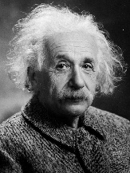
Genius Hour 6 P’s

Passion – What do you want to learn about? What do you think is interesting? What can you get excited about?

Pitch – How will you share your idea with the class? How will you get us on board?

Project – Who will be your outside expert? What materials will you need to complete the project? What will you need to do each day to reach your goals?

Product/Prototype – What did you create? What can you show us to demonstrate your learning?

Presentation – How do you plan to share your learning? Can you share your idea or project with others? What tools will you use to make your presentation engaging for the audience?

